Regenerating Joy’s thesis and Inbal’s 2012 paper figs.

Joy's thesis fig 12: | Legcy code
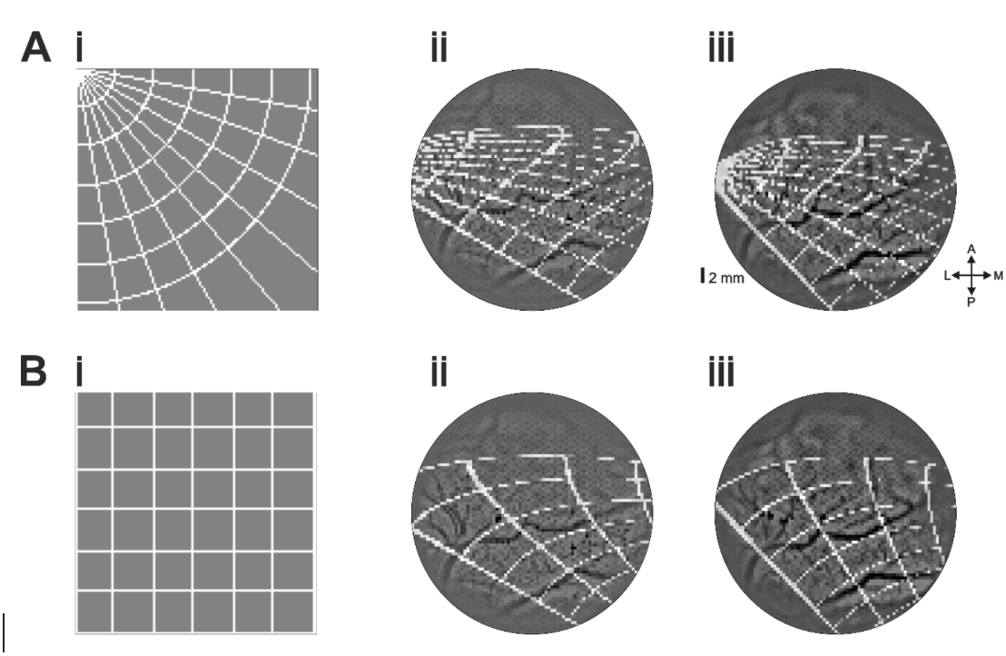 | 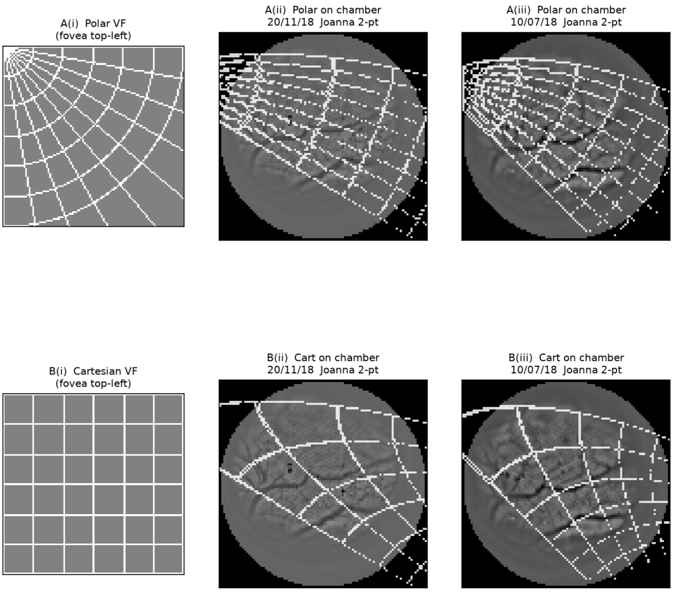

The letter D:

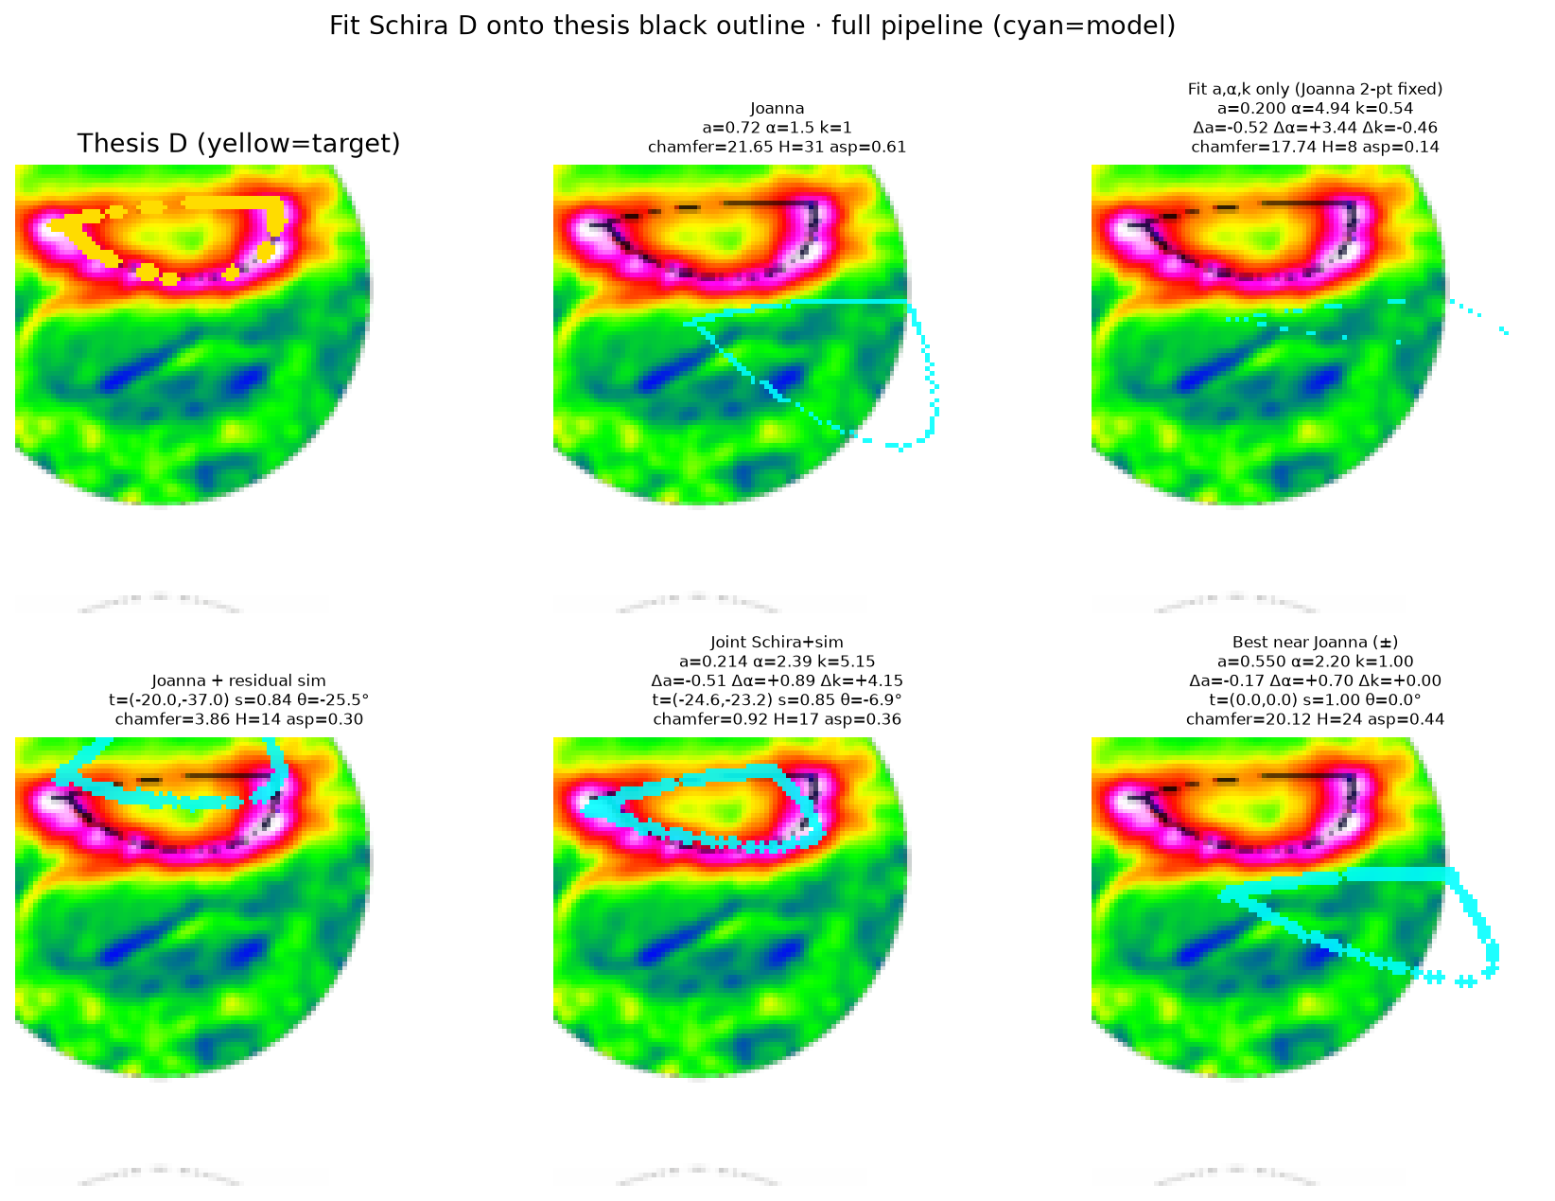

​

Legacy code reconstruction:​
​
​

